UML - Sequence Diagrams

Project: EasiLendar

The Very Best Meeting Planer

Creator: Manh Duy

Last update: 12/05/2015

Table of Contents

I. Sign in 3

II. Register 4

III. Search 5

IV. Appointment 6

V. Sync 7

VI. Calendar view 8

VII. Notification 9

VIII. Friend panel 10

IX. Sign out 11

# Sign in

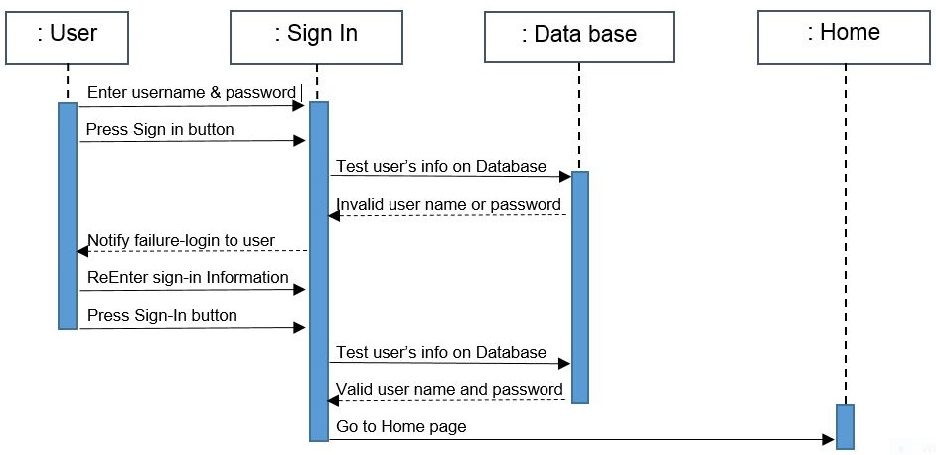

# Register

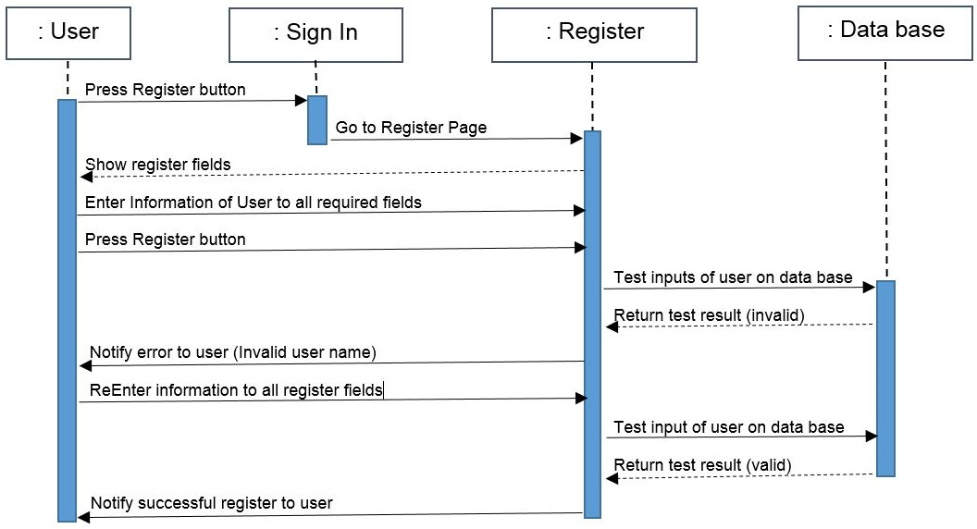

# Search

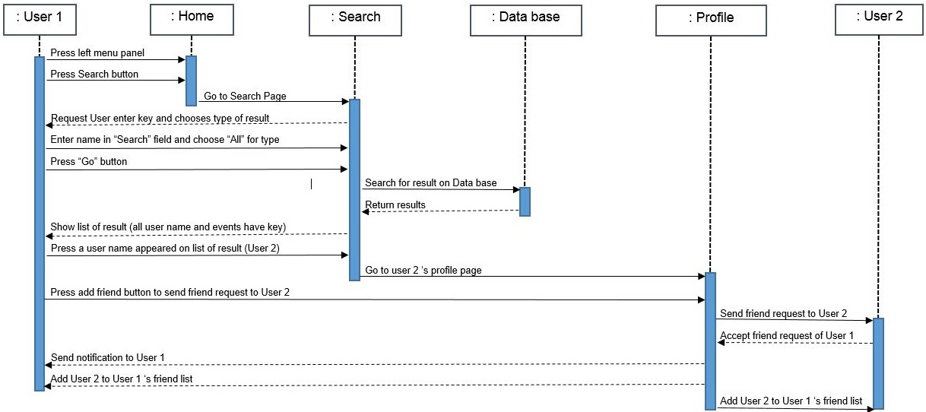

# Appointment

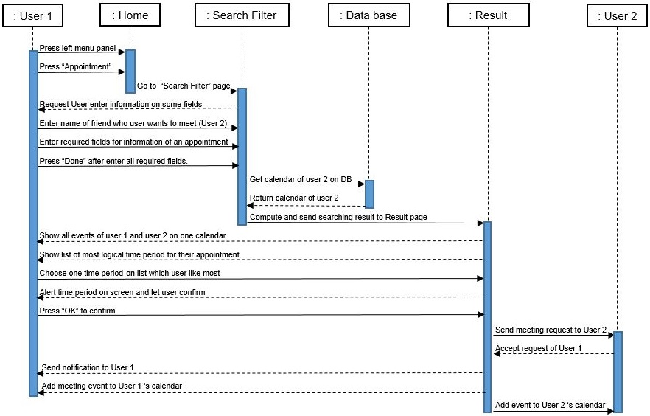

# Sync

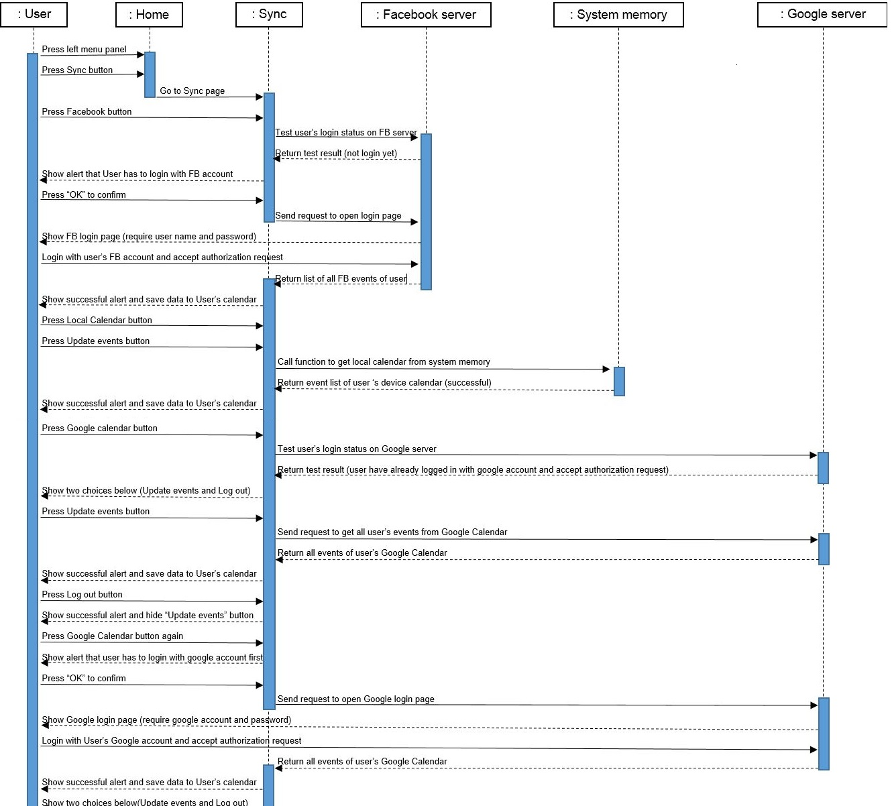

# Calendar view

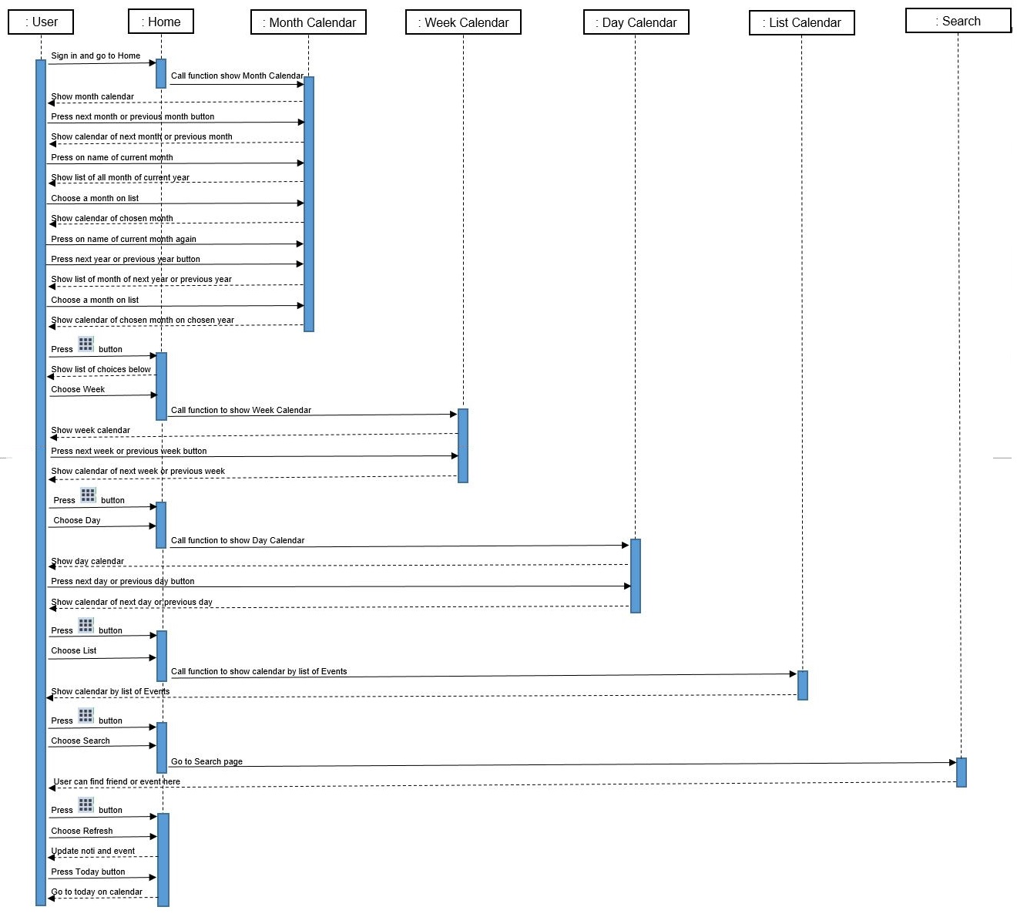

# Notification

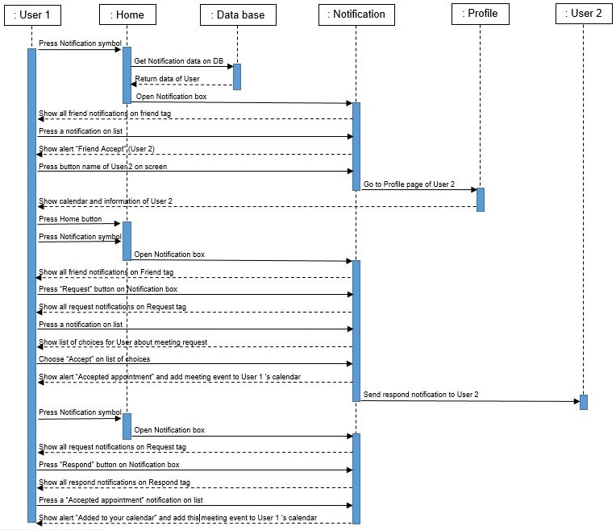

# Friend panel

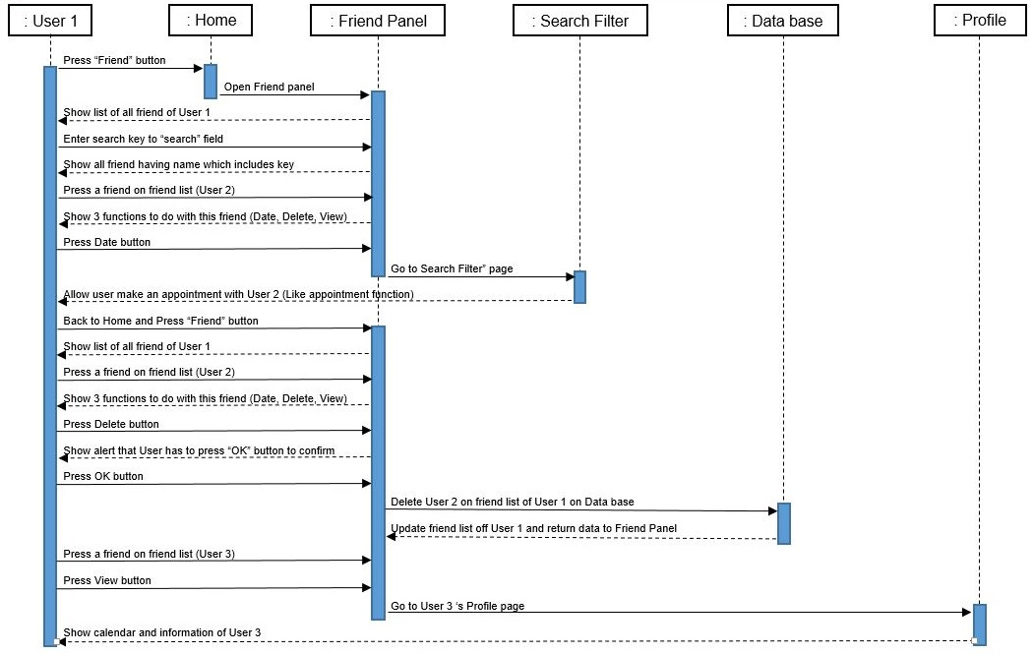

# Sign out

